Java OOP Section 2 – Banking App
Create the following Account class and properly JavaDoc. The code must have no warnings. You must have many meaningful GitHub commits by all programmers and invite dejohns2 to your group’s repository.
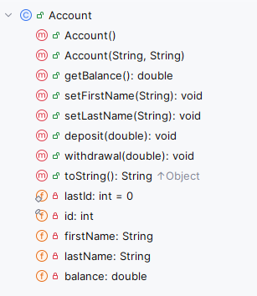
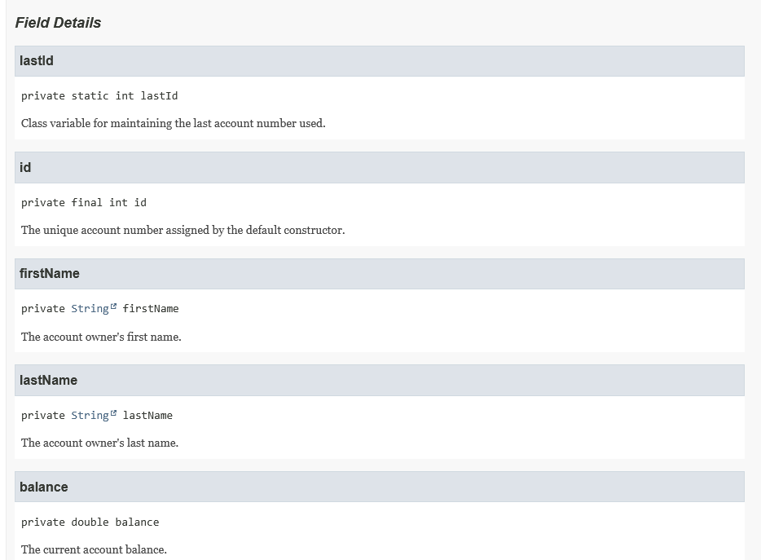
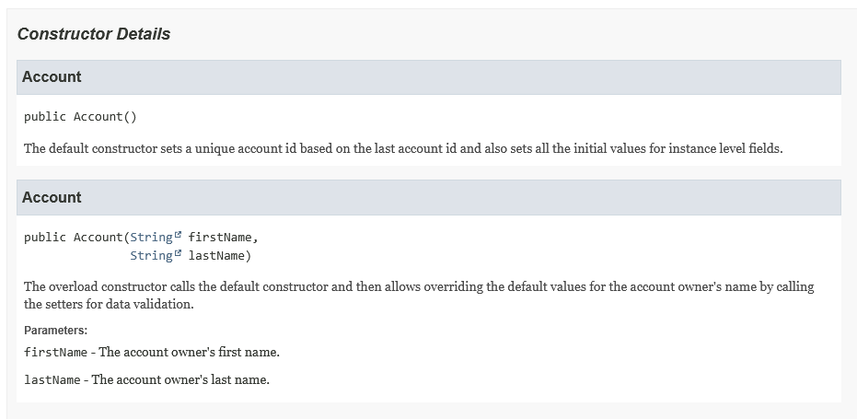
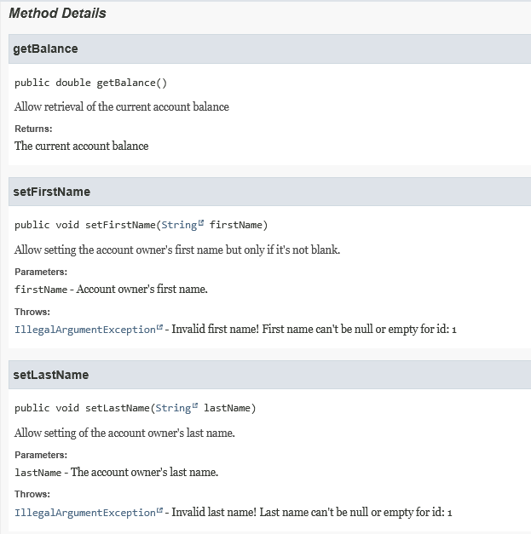
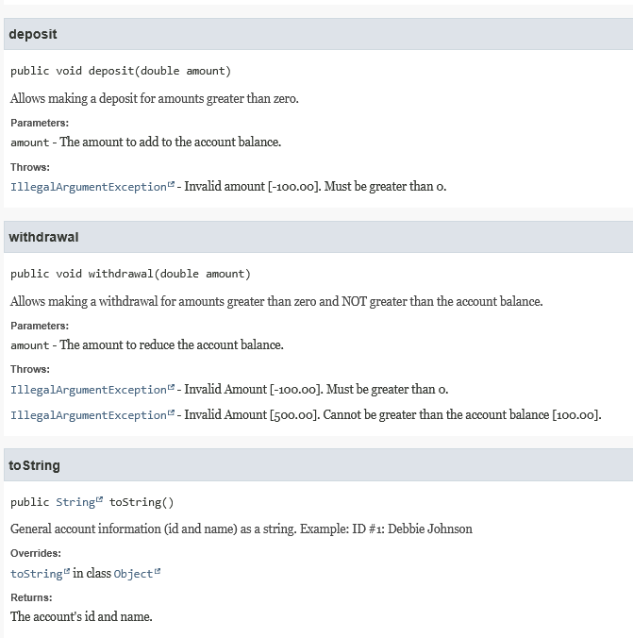

Help with toString: https://youtu.be/GvbdMwfjB98 Links to an external site.
Help with Constructors: https://youtu.be/ZD7CB6wKg8A
Example of how to throw an error:
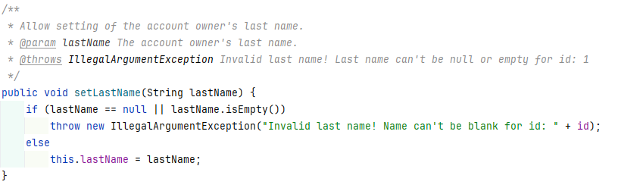
Once you have thoroughly tested the Account class, add the BankApp.java class to your project, and it should produce the following output EXACTLY.
================================================================================
Welcome to the Bank App!
================================================================================

What is your first name? Debbie
What is your last name? Johnson

--------------------------------------------------------------------------------
Account create! ID #1: Debbie Johnson
--------------------------------------------------------------------------------

Enter D=Deposit, W=Withdrawal, Q=Quit: no
Invalid option. Please try again.

--------------------------------------------------------------------------------

Enter D=Deposit, W=Withdrawal, Q=Quit: d
What amount would you like to deposit? 1000.3333
Invalid input. Please try again...
What amount would you like to deposit? -100.33
Invalid input. Please try again...
What amount would you like to deposit? 156.34
Deposit successful! Current balance: 156.34

--------------------------------------------------------------------------------

Enter D=Deposit, W=Withdrawal, Q=Quit: w
What amount would you like to withdraw? 200
Invalid amount [200.00]. It cannot be greater than the account balance [156.34].

--------------------------------------------------------------------------------

Enter D=Deposit, W=Withdrawal, Q=Quit: w
What amount would you like to withdraw? 50
Withdrawal successful! Current balance: 106.34

--------------------------------------------------------------------------------

Enter D=Deposit, W=Withdrawal, Q=Quit: q

Additional Assignment Requirements:
- Well-documented code, so make sure to update the class-level JavaDoc and add JavaDoc for any new methods.
Helpful resource for learning how to JavaDoc: JavaDoc: A Simple Overview (7:08 minutes)
- Must use GitHub
  - Invite me to your repository (dejohns2)
  - Numerous meaningful commits which will prove who did work
  - When working in groups, you must have balance work across code and README by switching often
  - Professional README.md
    - Fully explain what the program does
    - Embedded screenshots (stored in a subfolder)
    - Bullet point list of what new concepts were used
    - links to author’s profiles
How to embed an image:
![Program Output](assets/name_of_file.png)
How to link to an image or file:
[Program header level documentation](assets/name_of_file.png)
- PDF Peer or Self reviews in a GitHub subfolder. Use the person’s name as the file name. A peer review should focus on the person’s strengths and possibly providing helpful suggestions for future group work. A self review reflects on what you did well and what you could do differently on your next assignment.
- Attach your program file (Account.java) to the assignment along with your Good, Bad, and Ugly (GBU) reflection written at a college level. IMPORTANT: include your GitHub URL in this document.

